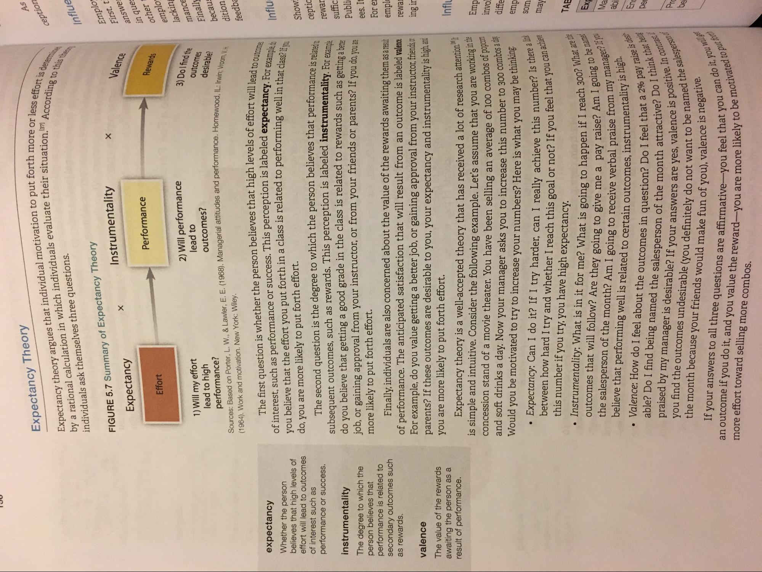
I
Expectancy Theory
As
Expectancy theory argues that individual motivation to put forth by a rational calculation in which individuals evaluate their situatio individuals ask themselves three questions.
it forth more or less effort
ception
tuation.371 According to the
ffort is determine
Influe
FIGURE 5.7 Summary of Expectancy Theory
Instrumentality Expectancy
Valence
Emplo First, t answe: in ques other emplo lacking
Performance
Rewards
Effort
2) Will performance 1) Will my effort
lead to lead to high
outcomes? performance? Sources: Based on Porter, L. W., & Lawler, E. E. (1968). Managerial attitudes and performance. Ho (1964). Work and motivation. New York: Wiley.
3) Dolfind the
outcomes
mance Finally becaus
desirable?
ormance. Homewood, IL: Irwin; Vroom
dition
feedba
The first question is whether the person believes that high levels of effort of interest, such as performance or success. This perception is labeled expectan you believe that the effort you put forth in a class is related to performing well in the do, you are more likely to put forth effort.
ofeffort will lead to outcome expectancy. For example de
o well in that class? If you
Influ
expectancy Whether the person believes that high levels of effort will lead to outcomes of interest such as performance or success.
Show:
ceptic
rewar suffic
instrumentality The degree to which the person believes that performance is related to secondary outcomes such as rewards.
The second question is the degree to which the person believes that performance subsequent outcomes, such as rewards. This perception is labeled instrumentality For do you believe that getting a good grade in the class is related to rewards such as getting shin job, or gaining approval from your instructor, or from your friends or parents? If you do you more likely to put forth effort.
Finally, individuals are also concerned about the value of the rewards awaiting them as a result of performance. The anticipated satisfaction that will result from an outcome is labeled valence For example, do you value getting a better job, or gaining approval from your instructor, friends, or parents? If these outcomes are desirable to you, your expectancy and instrumentality is high, and you are more likely to put forth effort.
Public ees. It For e
emplo
rewa
ing ir
valence
The value of the rewards awaiting the person as a result of performance.
Influ
Emp
Expectancy theory is a well-accepted theory that has received a lot of research attention. - is simple and intuitive. Consider the following example. Let's assume that you are working concession stand of a movie theater. You have been selling an average of 100 combos op and soft drinks a day. Now your manager asks you to increase this number to 300 cm
hinking Would you be motivated to try to increase your numbers? Here is what you may be
mbos a day
invol diffe emp som
is number? Is there a link you feel that you can achieve
may
Il reach 300? What are the se? Am I going to be namen se from my manager? If you
EX
Ma
instrumentality is high.
abi
• Expectancy: Can I do it? If I try harder, can I really achieve this number
between how hard I try and whether I reach this goal or not? If you feel that
this number if you try, you have high expectancy. . Instrumentality: What is in it for me? What is going to happen if I reach
outcomes that will follow? Are they going to give me a pay raise? And the salesperson of the month? Am I going to receive verbal praise To
believe that performing well is related to certain outcomes, instrumen . Valence: How do I feel about the outcomes in question? Do I feel that a
able? Do I find being named the salesperson of the month attracts praised by my manager is desirable? If your answers are yes, valence you find the outcomes undesirable (you definitely do not want to the month because your friends would make fun of you), valence
If your answers to all three questions are affirmative-you feel an outcome if you do it, and you value the reward you are more likely to more effort toward selling more combos.
De
nat a 2% pay raise is desir attractive? Do I think that bene alence is positive. In contras to be named the salesperson
you), valence is negative.
"To put for
that you can do it, you whe cely to be motivated to put

